C. Forecast Billing

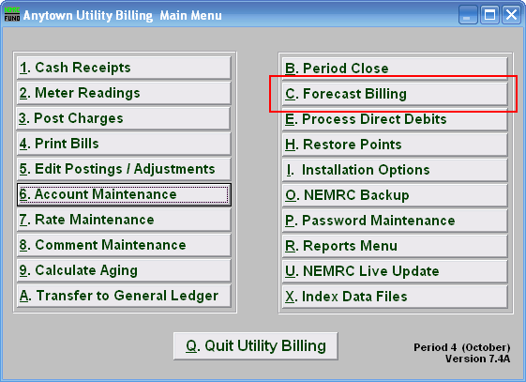
Click on “C. Forecast Billing” off the Main Menu, the following window will appear:

Forecast Billing

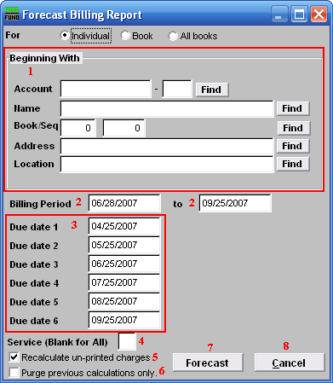
- Beginning With: If you choose “Individual,” choose the account you want to begin with. For additional help on finding accounts, refer to UB GENERAL ACCOUNT LOOKUPS. If you choose “Book,” choose the Book you wish to forecast billing for. If you choose “All Books,” this section will not be available.

- Billing Period: Select the starting date and ending date for the period which you want to calculate the billing for.

- Due date 1…6: Each of the due dates to be used in the calculation.

- Service (Blank for All): The service to show on this report. Leave blank to show all services. Services are defined in “I. Installation” from the Main Menu.

- Recalculate un-printed charges: Check the box to have all charges that have not yet been printed to get recalculated.

- Purge previous calculations only.: Check the box to delete all calculations that have already been computed but the bills were not printed.

- Forecast: Click “Forecast” to calculate the charges for this book at this time.

- Cancel: Click “Cancel” to cancel and return to the Reports Menu.

